PRACTICAL CLASS FOR COMPUTER BASE TRAINING (CBT) AND THE STUDENTS IT, JAMB, FORCES, ENTRANCE, SEMESTER AND COUNCIL EXAMINATIONS 2025 SESSION.

HISTORY OF COMPUTER:-
History of Computer: - The world of (“Computer”) was first recorded a being used 1613 and originally was used to describe human who performed calculations.
The definition of a computer remained the same until the end of the 19th century. When the industrial revolution gave rise to machine whose primary purpose was calculate.
Many different classifications computer was the first mechanical computer, create by (CHARLES BABBAGE) in 1822 Prof. in Mathematical Engineering.
- In 1837, (Charles Babbage) proposed the first general mechanical computer. The Analytical Engine the contained an Arithmetic Logic Unit (ALU). This computer was also never building while Charles Babbage was alive.
- In 1910, (Henry Babbage, Charles Babbage’s) youngest Son, was able to complete a portion of this machine and was able to perform basic calculations.
- The ZI was created by German (Kourad Zuse) in his parents living room between 1936 –1938.
It is considered to be first electromechanical binary programmable computer, and the first really functional modern computer.
- The turning machine was first purposed by (Alan Turing in 1936) and became the foundation for theory about computing and computers.
- The (Colossus) was the first electric programmable computer developed by (Tommy Flower), and first demonstrated in December 1943.
- The (Colossus) was created to help the British code breakers read encrypted German messages but was rot complete until 1946. It occupied about 1,800 square feet and used about 18,000 vacuum tables, weighing almost 50 tons. Although the judge rated that, ABC Computer was the first Digital Computer, many first Digital computers because it was fully functional.
- Nursing, profession that assumes responsibility for the continuous care of the sick, the injured, the disabled, and the dying. Nursing is also responsible for encouraging the health of individuals, families, and communities in medical and community settings.
- INFORMATICS: - Is the study of how information is generated, stored, processed, communicated, and used in natural and engineered systems It involves the interaction and design of information systems and their users, as well as the application of computation and data analysis to various fields, especially healthcare and life sciences It has computational, cognitive, and social aspects, and aims to solve complex problems and promote innovation.
- The definition provided by the American Nurses Association (ANA) and recommended by HIMSS has become widely referenced in response to the question, "What is nursing informatics?"
- WHAT IS NURSING INFORMATICS?
- According to the American Nursing Association (ANA), "Nursing informatics (NI) is the specialty that integrates nursing science with multiple information management and analytical sciences to “identify, define, manage, and communicate data, information, knowledge, and wisdom in nursing practice."
- Nursing informatics incorporates the fields of nursing, computer science, and information science in order to manage medical data and develop and maintain data systems that are designed to improve patient outcomes as well as boost the overall performance of a healthcare organization.

- IMPORTANT OF NURSING INFORMATICS
- Nurse informatics plays a prominent role in the development and maintenance of the technological solutions that nurses rely on to provide optimum patient care. In order to care for patients safely, nurses need reliable and efficient access to information such as lab results, medical histories, medication lists, physician notes, and more. A nursing informatics professional is responsible for overseeing the data systems where this information is stored. In addition to leveraging data to improve patient outcomes, a nursing informatics professional also employs data analytics to help improve the efficiency and reduce the costs of an organization's nursing operations.
- Healthcare organizations rely on data to make important decisions regarding patient care as well as procedural and financial decisions. By working to ensure that this vital data is collected, organized, analyzed, and implemented in the best way possible, nursing informatics is something that can improve multiple aspects of a healthcare organization's nursing processes, making it a highly important field in modern healthcare.

- DEFINITION OF ICT:-
INFORMATION AND COMMUNICATION TECHNOLOGY (ICT):- Can be defined as the hardware and software that enables data to be digitally processed, stored and communicated. It covers all advanced technologies in manipulating and communicating information. Computer based tools and techniques for gathering and using information.
- INFORMATION:-The use of computers to transform data into information,

- COMMUNICATIONS:-Transmission of information through networks, Technology; the know-how used for the transmission.

- TECHNOLOGY:-Technology is the application of conceptual knowledge for achieving practical goals, especially in a reproducible way. The word technology can also mean the products resulting from such efforts, including both tangible tools such as utensils or machines, and intangible ones such as software.

- WHAT IS A COMPUTER?
- DEFINITION OF COMPUTER:-
- COMPUTER: - Can be defined as an electronic device which accept (receive) data inform of input and process it and output it. Or

- A COMPUTER SYSTEM:-Is an electronic device which can input, process, output and stored data.
- For example:- when we visit an ATM, we enter our details like language, pin, amount to be withdrawn, etc. and then the final money which the cash dispenser releases is our outcome. In this case, the cash dispenser acts as an output unit.

- A picture of a computer
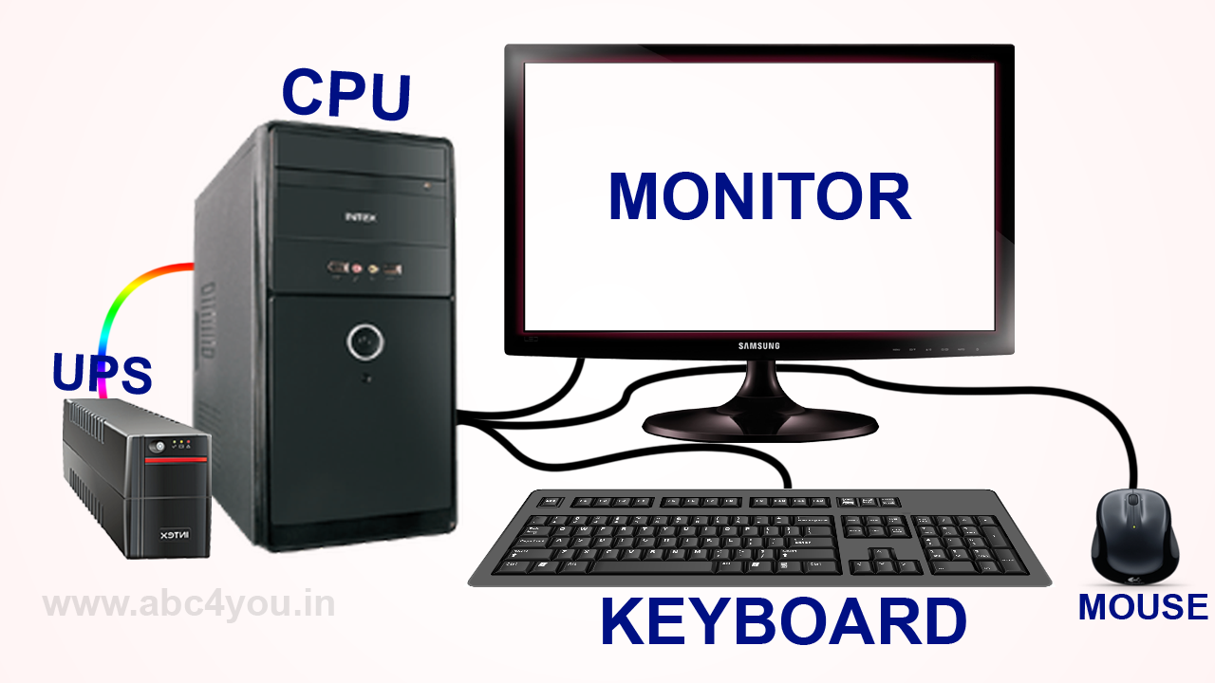
DATA: - Is a collection of un-organized facts, or is the collection of raw facts that are not organized, such as Words. Numbers, Images and Sounds. .
INFORMATION: - Is a data that is organized, has meaning and is useful.
E.g.: - Reports, Newsletters, a Receipts, a Pictures and a Check.
INPUT: - Data entered into a computer is called input, or any data or instruction you entered into the memory of a computer is called input.
OUTPUT: - The processed results are called output, or any text, graphics, videos, audio that you receive from the computer is called output.
STORAGE: - A computer also can hold data and information for future use in an area called storage.
E.g. draw ????????
USER: - A person that communicates with a computer or uses the information it generally is called a user.
E.g. draw ????
PROGRAM: - Set of information is called program.
E.g. draw ???

COMMON: - instruction given to any computer program is called common. 1+1=
E.g. draw ???
USER RESPONSE: - Is the given the response Yes/No, prompt message is called user response. E.g. draw???
WHAT DOES COMPUTER DO? /CHARACTERISTICS OF COMPUTER SYSTEM.
Why is a Computer a Powerful Tools?
Let's go over the characteristics of computers.
1. SPEED:- Executing mathematical calculation, a computer works faster and more accurately than human. Computers have the ability to process so many millions (1,000,000) of instructions per second. Computer operations are performed in micro and nano seconds. A computer is a time saving device. It performs several calculations and tasks in few seconds that we take hours to solve. The speed of a computer is measure in terms of GigaHertz and MegaHertz.
2. DILIGENCE:-A human cannot work for several hours without resting, yet a computer never tires. A computer can conduct millions of calculations per second with complete precision without stopping. A computer can consistently and accurately do millions of jobs or calculations. There is no weariness or lack of concentration. Its memory ability also places it ahead of humans.
3. RELIABILITY:- A computer is reliable. The output results never differ unless the input varies. The output is totally depend on the input. When an input is the same the output will also be the same. A computer produces consistent results for similar sets of data, if we provide the same set of input at any time we will get the same result.
4. AUTOMATION:-The world is quickly moving toward AI (Artificial Intelligence)-based technology. A computer may conduct tasks automatically after instructions are programmed.
By executing jobs automatically, this computer feature replaces thousands of workers. Automation in computing is often achieved by the use of a program, a script, or batch processing.
5. VERSATILITY:- Versatility refers to a capacity of computer. Computer perform different types of tasks with the same accuracy and efficiency. A computer can perform multiple tasks at the same time this is known as versatility. For example, while listening to music, we may develop our project using PowerPoint and Wordpad, or we can design a website.
6. MEMORY:- A computer can store millions of records. These records may be accessed with complete precision. Computer memory storage capacity is measured in Bytes, Kilobytes (KB), Megabytes (MB), Gigabytes (GB), and Terabytes (TB). A computer has built-in memory known as primary memory.

7. ACCURACY:-When a computer performs a computation or operation, the chances of errors occurring are low. Errors in a computer are caused by human's submitting incorrect data. A computer can do a variety of operations and calculations fast and accurately.
- A COMPUTER IS CALLED HARD WARE
A computer consist of a variety of hardware components that work together with software to perform calculations, organized data, and communicate with other computers. These hardware components include:-
Software is series of instruction that tells the hardware how to perform tasks. Without software hardware is useless, hardware needs the instructions provided by software to process data into information.
COMPONENTS OF A COMPUTER: A computer consist of a variety of hardware components that work together with software to perform calculations, organized data, and communicate with other computers. These hardware components include:-
1. Input Devices,
2. Output Devices,
3. A System Unit,
4. Storage Devices and
5. Communication Devices.
COMPONENT OF THE COMPUTER:-There are two types of components
1. Hardware components &
2. Software component.
1. HARDWARE: - Is a physical component part of the computer that we can seen and operate e.g.: - Keyboard, Mouse, Printer Speaker, Monitor, Microphone, Modem etc.

- [A] HARDWARE CLASSIFICATIONS:-

S. A. M.

M. M.

A. L. U

C. U.

INPUT

OUTPUT

1. SECONDARY AUXILIARY MEMORY (S.A.M):- It holds large amount of Data, Program and Information .They are needed for achieving portability and for storage space.
Types are: 1. Magnetic Disk: Hard Disk and Diskette (floppy Disk), and 2.Magnetic tape.
Types of Diskettes: - 3^{1/2} & 5^{1/4} can store 7.20 KB or 1.44 MB.
2. MAIN MEMORY (M.M):- The memory unit stores data and information either before, during or after processing.
(1) ROM &
(2) RAM.
3. THE ARITHMETIC AND LOGIC UNIT (A.L.U):- It performs all calculation (Addition, Subtraction, Multiplication & Division) and Logical Operations e.g. (>, <, <=, >=, and =).
4. CONTROL UNIT (C.U):- This direct and coordinate the activities of other parts of the system units it also issue instruction to them very well.
(2) SOFTWARE: - Is a physical component part of the computer that we cannot seen by our Naked eyes. E.g.:-Central Processing Unit (C.P.U.) & IC (Integrated Circuits) etc.
(B) SOFTWARE CLASSIFICATION:-
SOFTWARE

System Software Application Software

1. Operating System 1. Computer Package
2. Utilities Program/ Antivirus 2. Education
3. Translator 3.Disk Top Publishing Package

SYSTEM SOFTWARE: - they are programs that, enhance effective functioning of the computer system and the execution of other applications software.
E.g.:- Operating systems, Compilers, Assemblers, Spreadsheets Interpreter etc.
OPERATING SYSTEM: - Are special instructions that, control, manage, and coordinate the resources available on the computer system.
E.g.:- MS DOS (Micro-Soft –Disk-Operating- System), UNIX, MAC OS, WINDOWS an so on.
APPLICATION SOFTWARE: - They are programs written using higher level programming languages to carry out specific task. They are also referred to as application packages. They are specifically written to meet wide range of users requirements. E.g.:-
- Microsoft Word - for Typing Documents,
- Microsoft Access - for Database Query,
- Word Perfect - for Typing Documents,
- Microsoft Excel - for Database Record and
- Publishing - for Newspaper.
MEMORY: - Memory is a store where data and programs are kept, every computer has two types of memory, which are:-
1. Random Access Memory (RAM) and
2. Read Only Memory (ROM).
RAM: - Is the memory where all your work is held, while it being processed. The information in RAM is continuously altered as you load new applications or create and edit data in an application. That means, RAM doesn’t store information permanently hence it is called (Volatile) memory or primary memory/temporary memory.
While
ROM: - Information stored in ROM is permanent and help in the Power- On- Self-Test (POST) during booting. It is referred to as (Non- Volatile) Memory. Or Secondary Memory/Permanent Memory.
MEMORY: - Is measured in units called (Byte)/ (B), One (1) Byte may be considered equivalent one (1) character, for example the character (A-Z or @).
E.g.:- One (1) Byte may be considered equivalent to one (1) character,
One Kilobyte (1KB) is equivalent to 1.000 characters,
One Megabyte (1MB) is equivalent to 1.000 characters,
One Gigabyte (1GB) is equivalent to 1.000 characters, and
One Terabyte (1TB) is equivalent to 1.000 characters.
(1) INPUT DEVICES: - Allows a user to enter data and commands into the memory of the computer:-e.g.:- Keyboard, Mouse, Scanner, Optical Mark Reader, Microphone and a PC Camera or (Digital Cameras).
KEYBOARD: - A computer keyboard contains keys that allow you type Letters of the alphabet, Numbers, Spaces, Punctuation Marks, and other Symbols.
A computer keyboard also contains special keys that allow you to perform specific functions on the computer.
Eg:- ! @ # $ % ^ & * ( ).

A picture of a keyboard
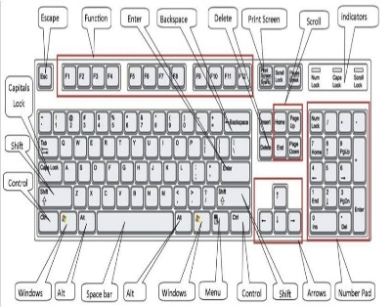
STRUCTURE AND FUNCTIONS KEYS ON THE KEYBOARD
1. Function keys,
2. Numeric keys,
3. Alphabetic keys,
4. Special keys,
5. Cursor keys and
6. Command keys
(A) DESKTOP KEYBOARD: - It has (101 to 106 keys)
(B) LAPTOP KEYBOARD: - It has (70 to 80 keys)
(C) TOGGLE KEY: - It consists as follows:-
1. CAPS LOCK,
2. NUM LOCK,
3. SCROLL –LOCK,
4. ALT,
5. CTRL,
6. SHIFT an so on.
- TYPES OF KEYBOARD
(1) Qwerty,
(2) Dvorak,
(3) Erogonomic and
4. Enhance keyboards.
All these keys normally found at OSHA.
(OSHA):- Occupation Safety and Health Administration.
Finally: - (Enhance key) normally has extra vacance on the top.
E.g.:-
ACQUAINTING YOUR SELF WITH THE KEYBOARD
Most of the keys on the keyboard are similar to those on a standard typewriter. When you type a character, the character appears on the screen.
The keyboard has additional keys that are not found on standard typewriters. These keys are used to perform specific computer- related tasks.
ESC:-The Escape key is often used to escape from a menu or command. Depend/like the application being used.
FUNCTION OF THE KEYS
These are the keys on the left or along the top of the keyboard that are labeled F1,F2,F3, F4,F5,F6 F7,F8,F9, F10,F11, and F12. These keys perform special functions depending on the application being used.
NUMERIC KEYS: - The numeric keys are also used when you want type a digit numbers on the keyboard. E.g.:- 1,2,3,4,5,6,7,8,9 and 0.
SPECIAL KEYS: - The special keys are normally used when you want type a
Special character on the keyboard.
E.g.:- ~,!, @, #, $, %, ^, &, *, (, and), _ , + an so on.
TAB KEY: - The tab key is similar to the keys on a typewriter most software uses {Tab} to advance to the next tab step.
CAPS LOCK KEY: - Similar to the shift lock key on a typewriter, {Caps Lock} allow you to set alphabet keys to Uppercase or Lowercase (Small letters/ Capital letters), {Caps lock} affect alphabet letters.

SHIFT, CTRL AND ALT KEYS: -hese keys are called (Boster Keys). They are used in conjunction with other keys on the keyboard to change the function key.
BACK SPACE KEY: - The back space key delete character to the left of the cursor.
ENTER KEY: -The Enter key is used to the computer, it is also known as
(Return Key).
DELETE KEY: - The delete key, delete character to the right of the cursor.
INSERT AND DELETE KEY: - The insert and delete keys are used to add or remove Colum or row in the table.

: (Up and Down, Left and Right keys) these keys allow you to move the cursor around the screen.
HOME KEY: - The home key moves cursor to the beginning of a line.
While,
END KEY: - The End key moves cursor to the end of a line.
PAGE UP: - This key moves the cursor one page up in an application.
PAGE DOWN: - This key moves the cursor one page down in an application.

Microsoft Word Shortcuts
CTRL A…………… Select All/ Highlight All (For Higher lighting All)
CTRL B…………… Bold (For Bold)
CTRL C…………… Copy (For Copy)
CTRL D…………… Font Style/ (For Naira Sign)
CTRL E……………. Centralise (For Center)
CTRL F…………… Find, (To Fine a File)
CTRL G……………. GO TO (for entering page no.)
CTRL H……………. Replace (fine with {Abubakar}) to (Replace with {Badamasi})
CTRL I…………… Italic (For Italic)
CTRL J…………… Justify (For Justify)
CTRL K……………. Insert Hypher Link
CTRL L……………. Left Alignment (For Align Left)
CTRL M……………. Tab
CTRL N……………. New Page
CTRL O……………. Open Existing Document
CTRL P…………… Print (For Printing Document)
CTRL Q…………… 1.15 LINE SPACING
CTRL R…………… Right Alignment (For Align Right)
CTRL S…………… Save (For Saving Document)
CTRL T…………… Left Indentation
CTRL U…………… Underline (For Under Line)
CTRL V…………… Paste (For Paste)
CTRL W…………… Close Window
CTRL X……………. Cut (For Cut)
CTRL Y………… Redo
CTRL Z…………… Undo (For undo)

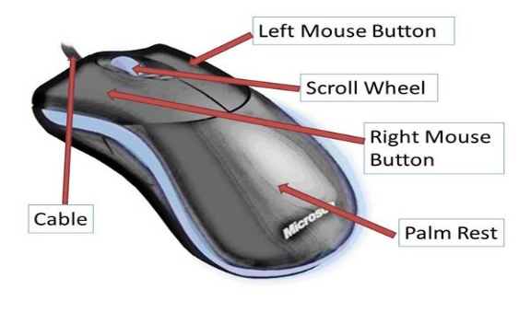
(B) MOUSE: - Is a small hand held devices that contains at least one button, also it has Left click and Right click.

The mouse controls the movement of a symbol on the screen called (pointer).
LEFT CLICK: - To select something or executed a command
While
REGHT CLICK: - It’s used to view the function.
HOW A MOUSE WORKS?
(1) Move the mouse across a flat surface.
(2) The pointer on the screen also move.
(3) Move the mouse to an object such as a button
(4) Press one of the mouse buttons to perform a certain action.
TYPES OF MOUSE: - There are two types of mouse
(1) Mechanical mouse and
(2) Optical mouse.
(a) Mechanical mouse: - it like->
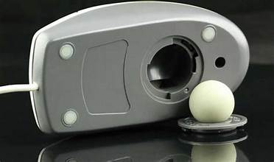
While
(b) Optical mouse: - likely -
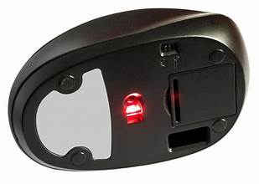

TRACK BALL:-Some users optical for alternative pointing devices other than a mouse as a track ball. Eg :-
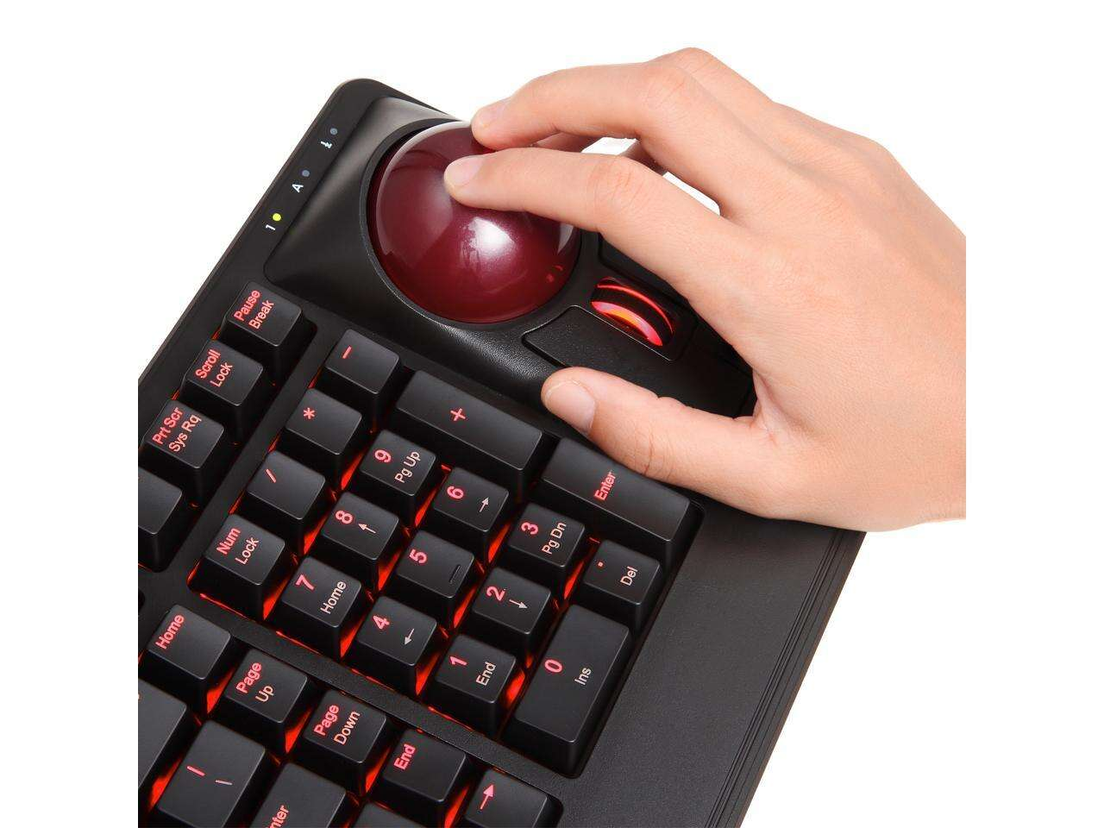
Wireless track ball
E.g.:- 
Bluthoot track ball
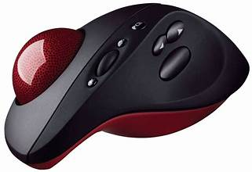

Usb tracball
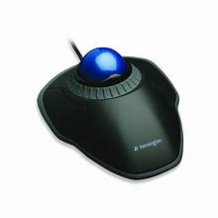

TOUCH PAD: - Is a small, flat, rectangular pointing devices, that is sensitive to pressure and motion, that normally on the laptop computer.
E.g.:-

STICK: - It is very small and pressure sensitive printing device shaped pencil eraser that is the first developed by I.B.M. (International Business Machine) for its lap top computer.
E.g.:-

JOYSTICK: - It’s normally used for Games, Driving or Flight an so on.
E.g.:-


TOUCH SCREEN: - A monitor that has a touch sensitive panel on the screen is called a touch screen. It normally touch with pen.
E.g.:-
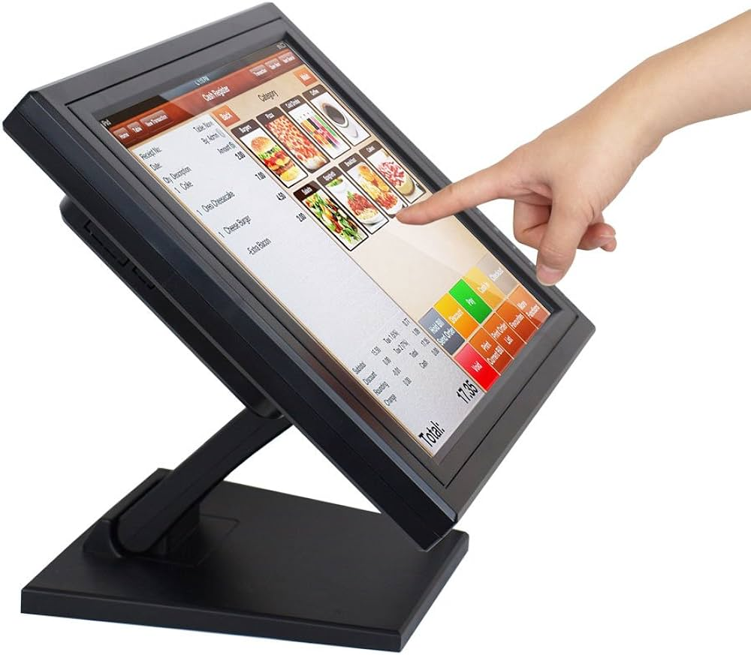

PEN INPUT: - Many input devices use an electronic pen instead of a keyboard or mouse for input.
E.g.:-
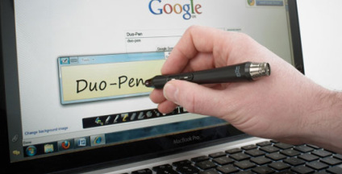

LIGHT PEN:-A light pen is a hand held input devices that contains a light source or can detect light.
E.g.:-

PEN COMPUTING: - Many hand held computers also allow you to input data using an electronic pen.
E.g.:-
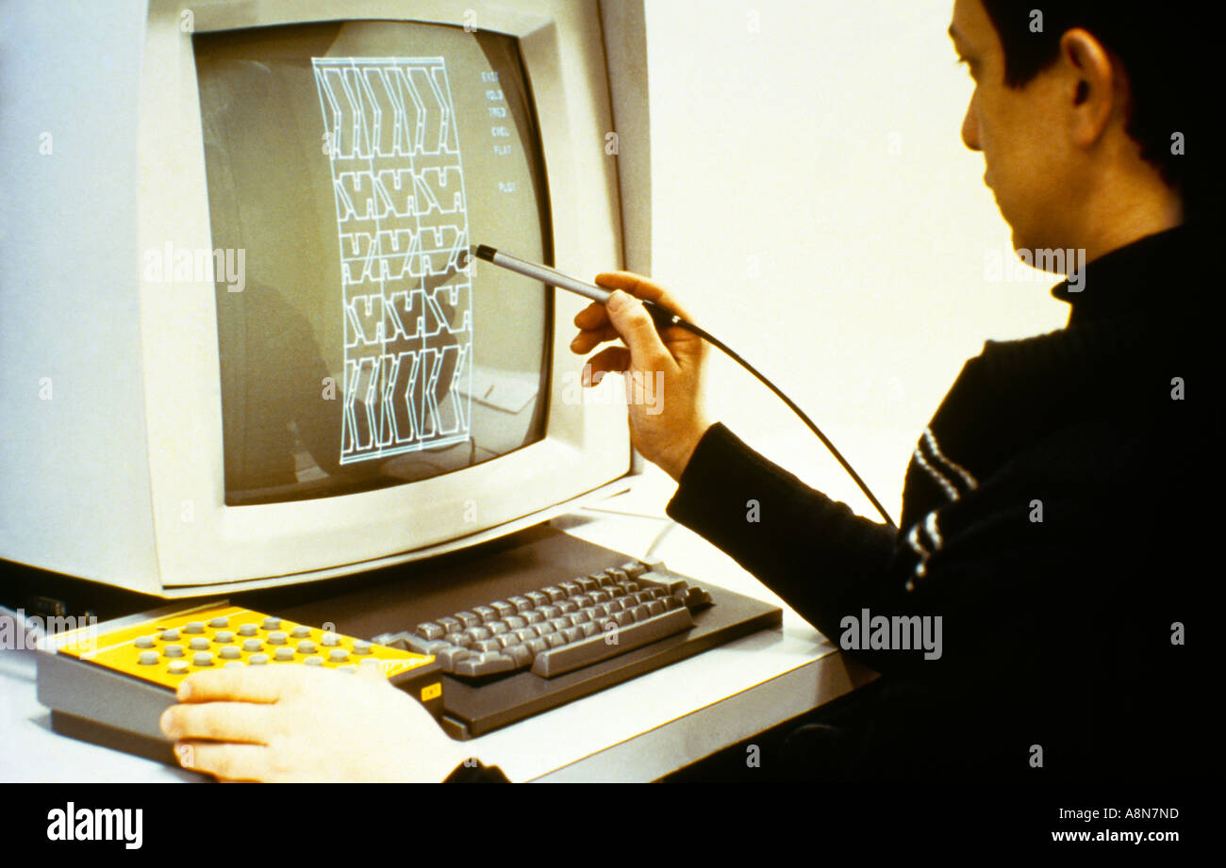

DIGITIZER: - It consist Graphical Tablet or Digitizer Tablet. All these are normally used for Graph or anything about drawing etc.
E.g.:-
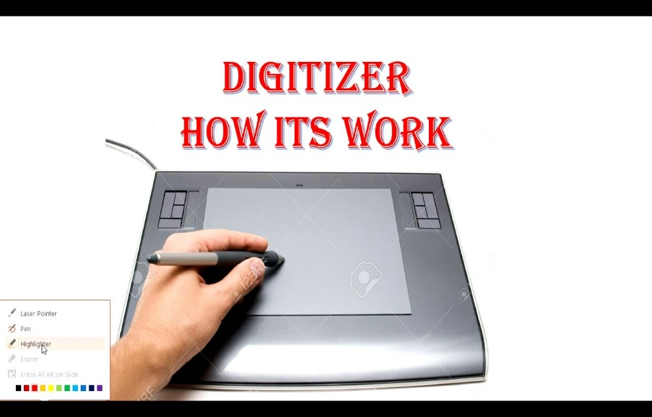
HOW TO START A COMPUTER?
The process of starting a computer is called (Booting). When you turn on the power, the computer first checks its memory and some other components after this, the disk drive will begin to spin and boot process will commence.
TO START A COMPUTER:-
- Make sure there is no diskette in the disk drives.
- Turn on the power, switches to all peripherals (Monitor, Printer) etc., and the computer.
- Watch the P.O.S.T. (Post-On-Self-Test) working the p.o.s.t. will be check the (RAM) and other devices. The system searches for DOS on drive A if no diskette is present in drive A. The system loads DOS from the hard disk the computer is now booted and ready for usage.
HARD DISKS: - Hard disk is a storage medium that retains data even when the computer is switched off.
Hard disks are made of a metal material and are housed inside the computer system unit. It has hdigher storage capacity and therefore more information can be stored on it.
The capacity of a hard disk is usually measured in megabytes they range in size between 100 MB and 20 GB or more. Since large volumes of information are stored on a hard disk it is important that a copy of all files be kept to prevent loss of the information through disk malfunction. This is called a back-up. The Hard Disk Drive is usually called drive C.
E.g.:-
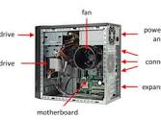
CD-ROM:-
CD-ROM (Compact Disk- Read Only Memory) is becoming a widely used method of storing computer information. They are gaining popularity because of their small size and ability to hold large amount of data.
A CD-ROM can hold approximately (600 MB) of data.
As the name suggests CD-ROM is a form of storage used for the retrieval of information. Once a CD-ROM has been created, it is not possible to alter or update the data on it. A CD-ROM Drive is usually called Drive D.
INSERTING AND REMOVING A CD
INSERTING A CD:-
To insert CD into the CD-ROM drive.
- Press the CD eject bottom. The CD- ROM tray opens.
- Hold the CD by its edges and place it carefully in the CD-ROM tray label side up.
- Press down on the CD until the disk locks on the spindle.
- Press the CD close bottom to close the drive.

REMOVING A CD:-
To remove CD from the CD-ROM drive
- Press the CD –ROM eject bottom
- Remove the CD and place it in its protective cover.
- Press the CD-ROM close bottom to close the drive.
CD-ROM PRECAUTIONS
- Store your CD’s in their original container.
- Do not bend a CD.
- Do not place heavy object on top of a CD.
- Do not apply a label to or otherwise mark the surface of a CD.
- Hold a CD by its outside edge.
- Do not expose CD’s to direct sunlight or extreme cold or heat.
- To clean a dirty CD wipe it with a clean and dry cloth.
+
2. SOFTWARE: - Software is a collection of computer programs and related data that provide the instructions to a computer on what to do and how to do it. It is the non-physical components of a computer system.
Types of Software: - System Software and Application Software.
System software is a type of computer program that is designed to run a computer's hardware and application programs. If we think of the computer system as a layered model, the system software is the interface between the hardware and user applications.
APPLICATION SOFTWARE:- is a type of computer program that performs a specific personal, educational, and business function. Each application is designed to assist end-users in accomplishing a variety of tasks, which may be related to productivity, creativity, or communication.
Application Software divide in to two.
General purpose application Software: It is not limited to one particular function. They provide large no of features for its users. For example, a word processor could be classed as general purpose software as it would allow a user to write a novel, create a restaurant menu or even make a poster.
Special purpose application software: is a type of software created to execute one specific task. For example, a camera application on your phone will only allow you to take and share pictures. Another example would be a chess game, it would only allow you to play chess.

- CATEGORIES OF COMPUTERS
Classification of Computers
1. Classification by Purpose,
2. Classification by (Types) Function,
3. Classification by Size and Power and
4. Classification by Age.

a. CLASSIFICATION BY PURPOSE: Computer are either general purpose or specific purpose.
i. General Purpose Computers: - Are designed to perform a range of tasks. They have the ability to store numerous programs but lack in speed and efficiency.
ii. Specific Purpose Computers:-Are designed to handle specific problem or perform a specific task.

b.CLASSIFICATION OF THE COMPUTER BY (TYPES) FUNCTION: This is classification based on the type of instruction and form of input data that computers accept and process. These are:- Digital, Analog and Hybrid Computers.
1. DIGITAL COMPUTER
These are computers that solve problem by counting digits (numbers) just as a person does when counting with fingers. This machine can Add, Subtract, Multiply and

Divide. It uses discrete, data or digits and count things. They convert data to binary (numbers) i.e 0’^{s} and 1’^{s}
2. ANALOG COMPUTER
This are computer that solve problem by measuring one quantity in terms of another quantity. It uses continuous data. These are mostly found in Hospitals and Manufacturing Industries.
3. HYBRID COMPUTER
These are computer that combine Digital and Analog features. That is they perform the functions of both the Analog and Digital computers.

c. CLASSIFICATION OF COMPUTER BY (SIZE) AND POWER: Computer are grouped into Three (3) are four types in the classifications of the computer by size:
(1. Micro Computers.2. Mini Computer, 3. Mainframe Computer. ) the grouping is informed by their size, cost, memory capacity and speed.
1. MICRO COMPUTERS:-They are known as personal computers (PC’s), they are potable, less expensive, not multi-tasking,not multi-users and the memory cames in chips. It’s (CPU) is based on a microprocessor.
2. MINI COMPUTER:--They are special purpose computers, they are bigger and they also have greater memory capacity, they are multi-tasking, multi-users, not very large in size, greater memory capacity, expensive and movable.

3. MAINFRAME COMPUTER:-They are very large computers with large internal memory and have a great speed. They are mainly used in large establishment. Such as Schools, Banks and Factories, they need a special environment to operate.
They are multi-tasking, multi-users, very large, very higher memory capacity, very expensive and are not easily transferable because of their big size.
d. CLASSIFICATION OF COMPUTER BY AGE: - Therefore, computers can be divided into five generations depending upon the technologies used. These are:
1. First Generation (1940 - 1956)
2. Second Generation (1956 - 1963)
3. Third Generation (1964 - 1971)
4. Fourth Generation (Since 1971)
5. Fifth Generation (Since 1980)

- NETWORKS & THE INTERNET:-
When you buy a new computer, the first thing you’ll probably try to do is connect to the Internet. To do this, you establish a connection to your (router), which receives the data from the Internet and then forwards it to the computer.
Of course that’s not all: Next, you could also connect your PRINTER, SMARTPHONE or TV to the router so that these devices are also connected to the Internet. Now you have connected different devices to each other via a central access point and created your own network.

WHAT IS A NETWORK?

In Information Technology:-, a network is defined as the connection of at least two computer systems, either by a cable or a wireless connection. The simplest network is a combination of two computers connected by a cable. This type of network is called a (peer-to-peer network).
There is no hierarchy in this network; both participants have equal privileges. Each computer has access to the data of the other device and can share resources such as disk space, applications or peripheral devices (printers, etc.).
Today’s networks tend to be a bit more complex and don’t just consist of two computers Systems with more than ten participants usually use client-server networks. In these networks, a central computer (server) provides resources to the other participants in the network (clients).
- DEFINITION OF NETWORK
A network is a group of two or more computers or other electronic devices that are interconnected for the purpose of exchanging data and sharing resources.

Network example: your home Wi-Fi
The Wireless LAN (Wireless Local Area Network, i.e. the Wi-Fi network) in your home is a good example of a small (client-server network). The various devices in your home are wirelessly connected to the router, which acts as a central node (server) for the household. The router itself is connected to a much larger network: the Internet.
Since the devices are connected to the router as clients, they are part of the network and can use the same resource as the server, namely the Internet. The devices can also communicate with each other without having to establish a direct connection to each device. For example, you can send a print job to a Wi-Fi-enabled printer without first connecting the printer to the computer using a cable.
Before the advent of modern networks, communication between different computers and devices was very complicated. Computers were connected using a LAN cable. Mechanical switches were used so that peripheral devices could also be shared. Due to physical limitations (cable length), the devices and computers always had to be very close to each other.
Note
If you need an extremely stable connection you should consider the possibility of a wired connection to the router or device, despite the advantages of Wi-Fi.

WHAT ARE THE TASKS AND ADVANTAGES OF A NETWORK?
The main task of a network is to provide participants with a single platform for exchanging data and sharing resources. This task is so important that many aspects of everyday life and the modern world would be unimaginable without networks.
Here’s a real-life example: In a typical office, every workstation has its own computer. Without a network of computers, it would be very difficult for a team to work on a project since there would be no common place to share or store digital documents and information, and team members would not be able to share certain applications.
In addition, many offices only have one printer or a few printers that are shared by everyone. Without a network, the IT department would have to connect every single computer to the printer, which is difficult to implement from a technical standpoint. A network elegantly solves this problem because all computers are connected to the printer via one central node.
The main advantages of networks are:-
- Shared use of data
- Shared use of resources
- Central control of programs and data
- Central storage and backup of data
- Shared processing power and storage capacity
- Easy management of authorizations and responsibilities

HOW DOES A NETWORK WORK?
In a typical client-server network there is a central node called the server. The server is connected to the other devices, which are called clients. This connection is either wireless (Wireless LAN) or wired (LAN).
In a typical home network, the router assumes the role of the server. It is connected to the Internet and provides the “Internet” resource for the other devices (computers, smartphones, etc.).The router combines all wired and wireless devices in a local network.

CLIENT-SERVER ARCHITECTURE
In larger networks, such as corporate networks, the server is usually a central computer. This computer is used exclusively for running special server software and services, not regular applications and programs. The server must operate continuously, whereas the other computers (clients) can be switched off.
The server and the client communicate as follows in this server-based network: The client first sends a request to the server. The server evaluates the request and then transmits the response. In this model, the client always connects to the server, never the other way around.

NETWORK PROTOCOLS
Network protocols Ensure smooth communication between the different components in a network. They control data exchange and determine how communication is established and terminated as well as which data is transmitted. There are usually multiple network protocols that each perform a specific subtask and are hierarchically organized into layers.

NETWORK ADDRESSES
In addition, it is necessary to ensure that the transmitter and receiver can be correctly identified. Network addresses are used for this purpose. In computer networks, each computer typically has an IP address, similar to a telephone number that uniquely identifies the computer. This internal IP address is used only for communication between the participants in the local network. For communication on the Internet, external IP addresses are used that are automatically assigned by the Internet provider.
A distinction is also made between IPv4 and IPv6 addresses. IPv4 addresses used to be standard, but only a total of around 4.3 billion of these addresses could be assigned before they were exhausted. Due to the massive expansion of the Internet, additional IP addresses were urgently needed. Therefore, the new IPv6 standard was developed, allowing up to 3.4 x 10³⁸ (340 sextillion) addresses. This should be sufficient for the future.
You can find detailed information on the IP protocol and its important role in computer networks in our article “What is the Internet Protocol?”.

WHAT TYPES OF NETWORKS ARE THERE?
Networks are usually divided into different network types according to transmission type and range, that is, depending on how or how far the data is transmitted.

1. WIRELESS VS. 2. WIRED
Networks are classified by transmission type as either wireless or wired. Examples of wireless networks include Wi-Fi networks based on the IEEE 802.11 standard, or the LTE networks used for mobile devices and smartphones. Wired networks such as DSL are also known as broadband Internet.

NETWORK RANGE
NETWORKS ARE TYPICALLY CLASSIFIED BY RANGE AS FOLLOWS:
- Personal Area Network (PAN): A PAN is used for interconnecting devices within a short range of approximately 10 meters.
Examples include Bluetooth technology or Apple’s Airdrop ad hoc Wi-Fi service.
- Local Area Network (LAN): Local area networks are among the most widespread networks and are used in households or small and medium-sized companies.
- Metropolitan Area Network (MAN): These types of networks cover cities or single geographic regions.
- Wide Area Network (WAN): The nationwide broadband or cellular network in the US is an example of a Wide Area Network.
- GAN (Global Area Network): The best known example of a global network is the Internet.
Note that there is some overlap between the different network types: As a Wi-Fi user, you are simultaneously part of a WAN and a GAN when you’re connected to the Internet.
- INTERNET:-
The Internet is a global network of billions of computers and other electronic devices. With the Internet, it's possible to access almost any information,
The Internet (or internet) is the global system of interconnected computer networks that uses the Internet protocol suite (TCP/IP) to communicate between
What is the internet? Short answer: a distributed packet-switched network. This is the introduction video to the series, "How the Internet ...

THE DIFFEREN TYPES OF INTERNET CONNECTION
To get connectivity, there are many types of internet connections with different speed ranges and purposes.

1. BROADBAND CONNECTION
This type of internet connection provides high-speed internet access which allows faster dial-up access. It is provided via telephone composition or cable without the need for a telephone connection. Due to this, we can use the telephone and internet simultaneously. Broadband can be accessed by multiple people at the same time.

2. DIAL UP CONNECTION
It is a traditional type of internet connection that is established between computer and an ISP using a modem. It is an inexpensive internet connection type that is slow in speed. For accessing
internet connection through a dial-up connection, telephone connection is needed since phone number is required on the computer.
Along with that, a modem is required since it acts as an interference between computer and telephone line.

3. DIGITAL SUBSCRIBER LINE (DSL)
DSL provides is one of the types of common internet connectivity. It is an internet connection via telephone network that does not require dialing phone number to connect. It uses a router for transporting data with the connection speed of 128 Kbps to 8 Mbps. This type of internet connection is capable of translating data at 5 Mbps.
The services of DSL can be simultaneously delivered with wired telephone service on same telephone line due to high frequency bands for data. It uses existing 2-wire copper telephone line that is connected to home service as well as landline telephone service. It is always ‘on’ and does not require phone number to connect.

4. CABLE
Cable is a form of broadband access cable modem that provides extremely fast access to internet. Connection speed varies depending on uploading and downloading data. It uses cable modem for providing internet connection ranging from 512 k to 20 Mbps and it operates over cable TV lines.
- DIFFERENCE BETWEEN WWW AND INTERNET
The main difference between WWW and Internet is that WWW (World Wide Web or Web) is one of the various services offered by the Internet in order to share information.

5. WI-FI
Also known as Wireless, it does not require telephone lines or cables for internet connection but rather uses radio frequency. Wifi is based on IEEE 802.11 standards that allow electronic devices to connect with internet. Just like a dial-up connection, it is always on and can be accessed. These types of internet connection provide access to internet connectivity over WLAN through a router that connects to ISP.
This type of internet connection utilizes electromagnetic waves for transmitting networks.

6. INTEGRATED SERVICES DIGITAL NETWORK (ISDN)
ISDN allows users to transmit video, audio and data over standard or digital telephone lines. For transmission in this type of internet connection requires the installation of ISDN adapter at both ends, including the user and Internet service provider. One of the important features of ISDN is that it is capable of integrating speech and data on same lines.
It is a circuit-switched telephone network system that provides access to packet-switched network to allow digital transmission of data and voice. It results in a better data and voice quality in comparison to any analog phone. Here, packet-switched connections for data are provided in increments of 64 kilobit/s. The maximum bandwidth is 128 kb it/s in upstream and downstream directions.

7. CELLULAR TECHNOLOGY
It provides wireless internet access through cell phones with speed varying according to the ISP. Cellular technology enables mobile communication since it uses a complex two-way radio
system between mobile and wireless networking. This technology utilizes radio frequencies repeatedly throughout the market with the least interference to serve simultaneous conversations.
The most commonly provided speed is 3G and 4G, where 3G is a third-generation cellular network that obtains mobile speed of approximately 2 Mbps. 4G is the fourth generation of the cellular wireless standard to achieve peak mobile speed of 100 Mbps. However, at present, it is around 21 Mbps.

- ABOUT COMPUTER BASE TRAINING (CBT)
The Computer Base Training (CBT) is a way of showing the student how to practices/operate the System, and it’s have the ways which specialized in rendering technological services as follows:-
1. Computer base training (CBT),
2. Internet training,
3. Online business training,
4. Order and pre-order services and
5. Others professional technological services along with general care literacy.

MISSION
The organization was aimed in rendering internet and technological services to the persons with low computer literacy and those that does not have the knowledge of it at all.

VISION
To minimize the rate of poor computer literacy amongst the higher tertiary institutions graduate student and all the cbt aspirants which will help in reducing the failure of cbt examinations.
ABOUT THE CBT, IT, JAMB AND FINAL YEAR EXAMINATION TRAINING
CBT EXAMINATION TRAINING:- is a training programme that organized for the prospective IT, Jamb, Cbt and Final Student (Candidate) that are seeking for Admission into any University or other Tertiaries Institution in Nigeria and world in general.
- WHY THE PRACTICAL TRAINING?
Because it is obvious that most of the students lacks computer literacy and as a result of this many students used to face some challenges that led them to failure. For lacking the knowledge on how to operate/uses a computer, therefore, the training was aimed to give the CBT Candidates computer literacy on how to seat for their CBT Exams confidently.

- HOW TO START A PRACTICAL CBT?
ACQUAINTING YOUR SELF WITH THE SYSTEM (COMPUTER)
Most of the keys on the keyboard are similar to those on a standard typewriter. When you type a character, the character appears on the screen.
The keyboard has additional keys that are not found on standard typewriters. These keys are used to perform specific computer- related tasks.
The process of starting a computer (just turn on the system from main switch, Stabilizer, ups, Monitor Screen and other peripherals) this process is called (Booting).when you turn on the computer, the Computer first checks it’s memory and some other components.
After this, go to your Browser (Chrome, Edge, Firefox an so on) then type your (IP address) on your Google search Eg:- (192.168.1.2/moodle/login/index.php)
The dialog box will appear as showing bellow:-

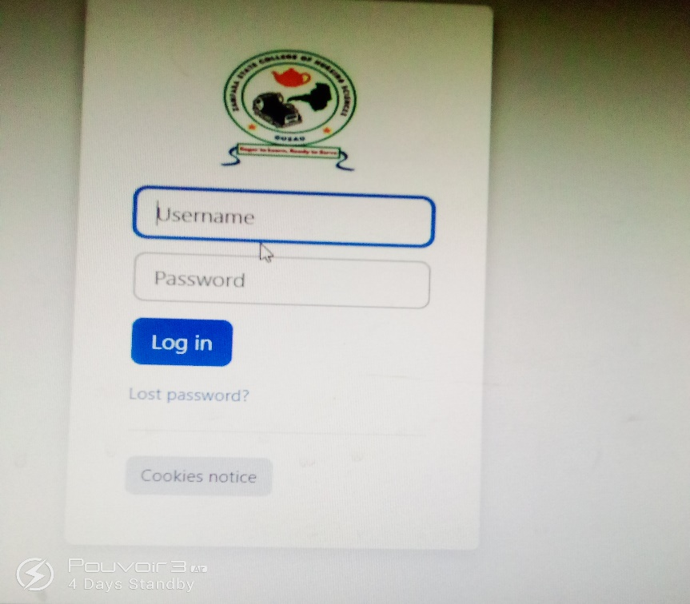

After that , just type your User name and password then login

Eg:-
J ttttttttttggg6\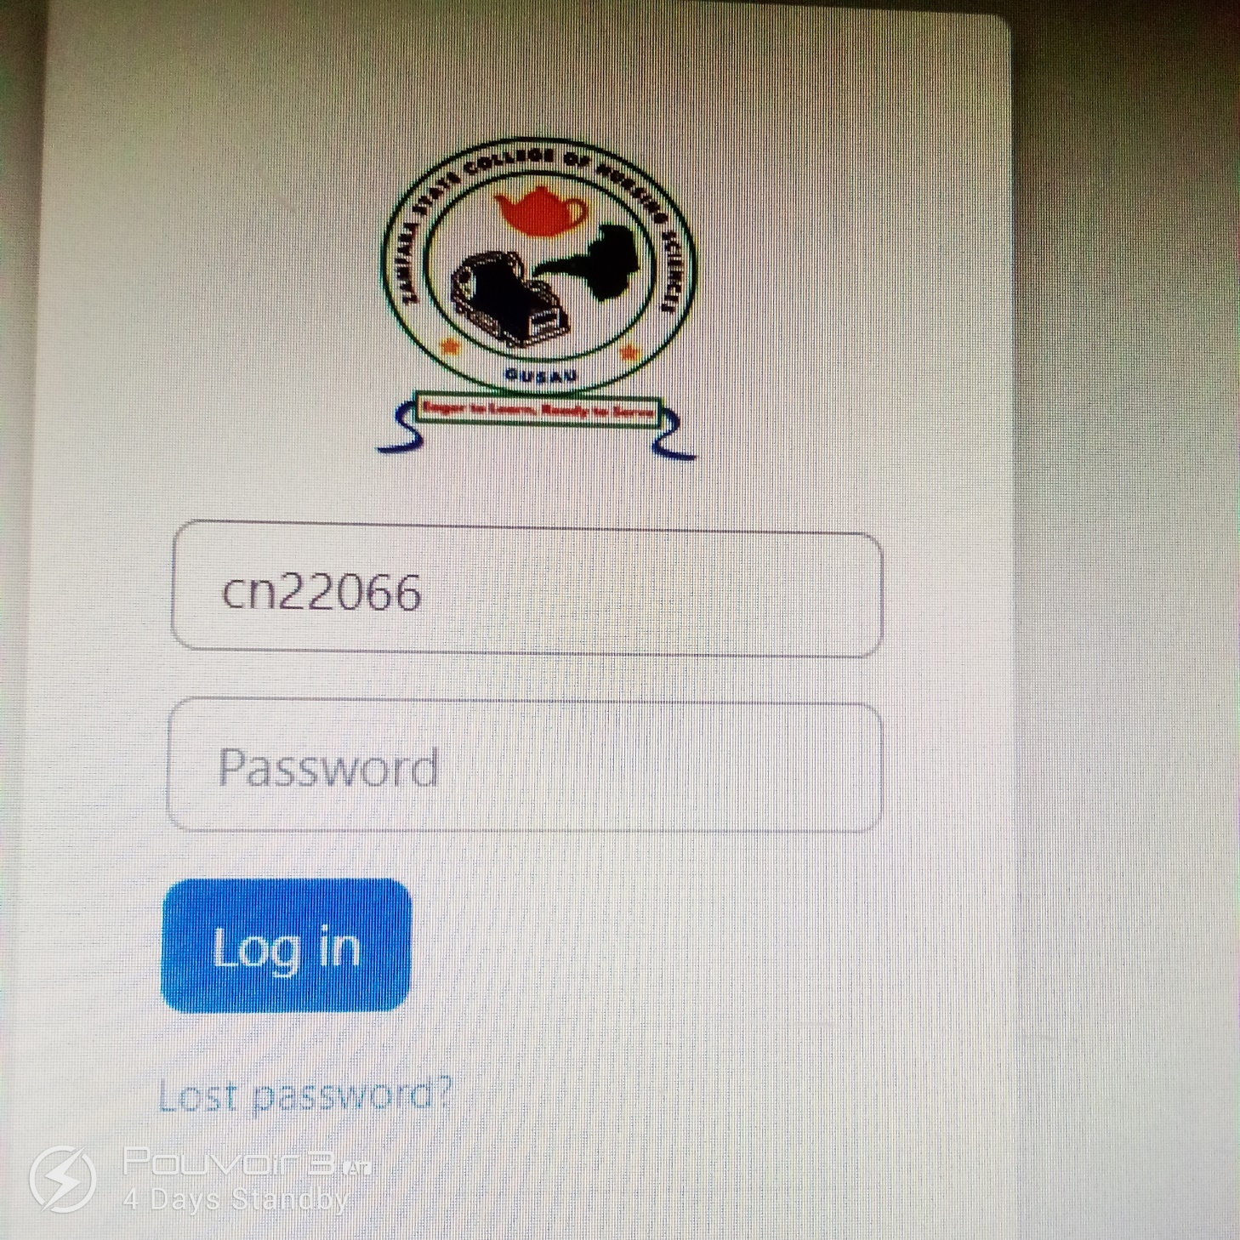

When you login, it will welcome you (welcome back), then your name also and dialog box blue, will appear on the screen.
Eg:-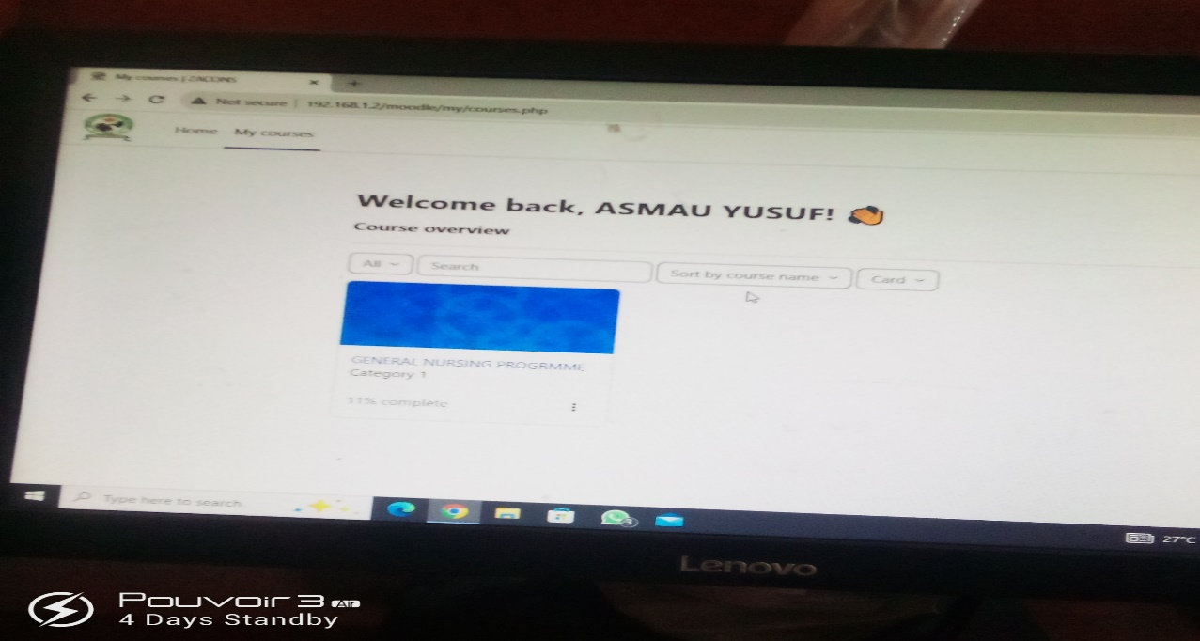
After that, click on dialog box blue, then it will take you to:-
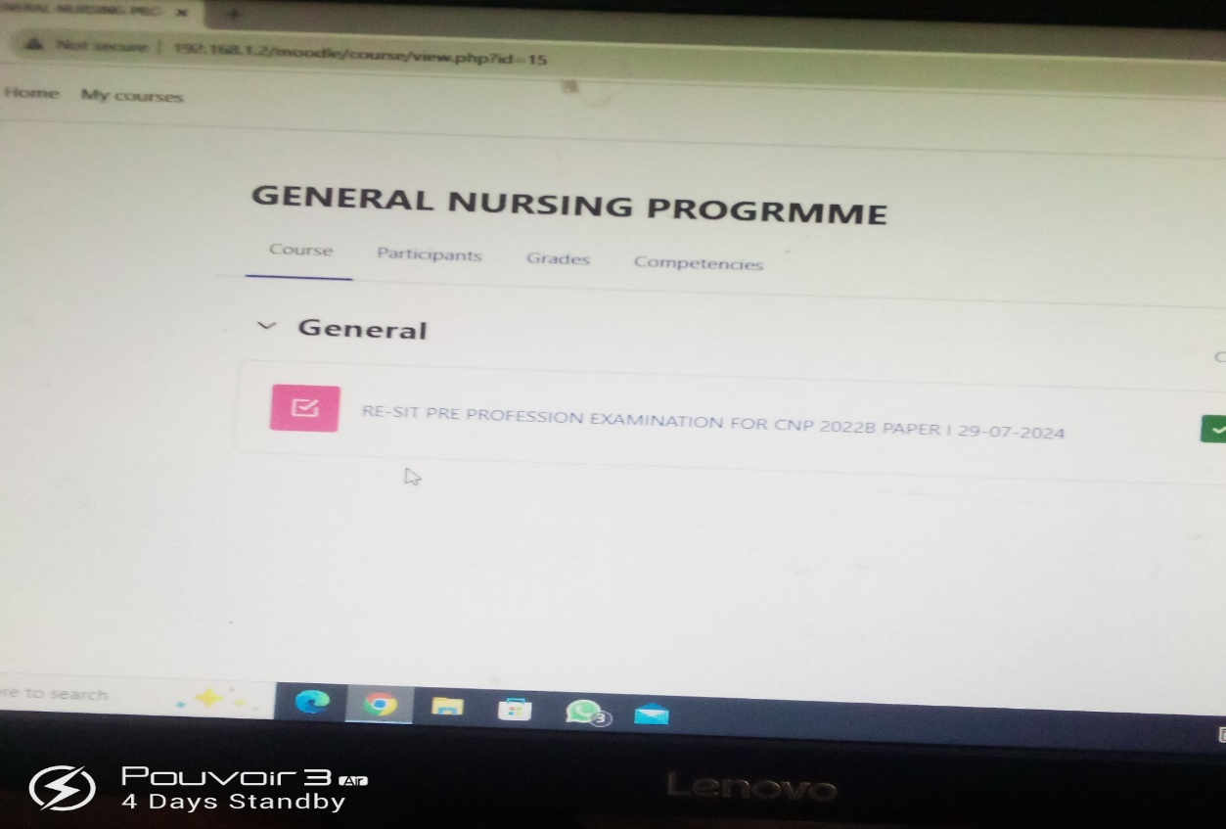
When you click the red bottom on the screen it will ask you to
- (Got it)
- then (Attempt quiz)
- and finally (Start Attempt or Attempt exams).

After that, see as showing bellow:-
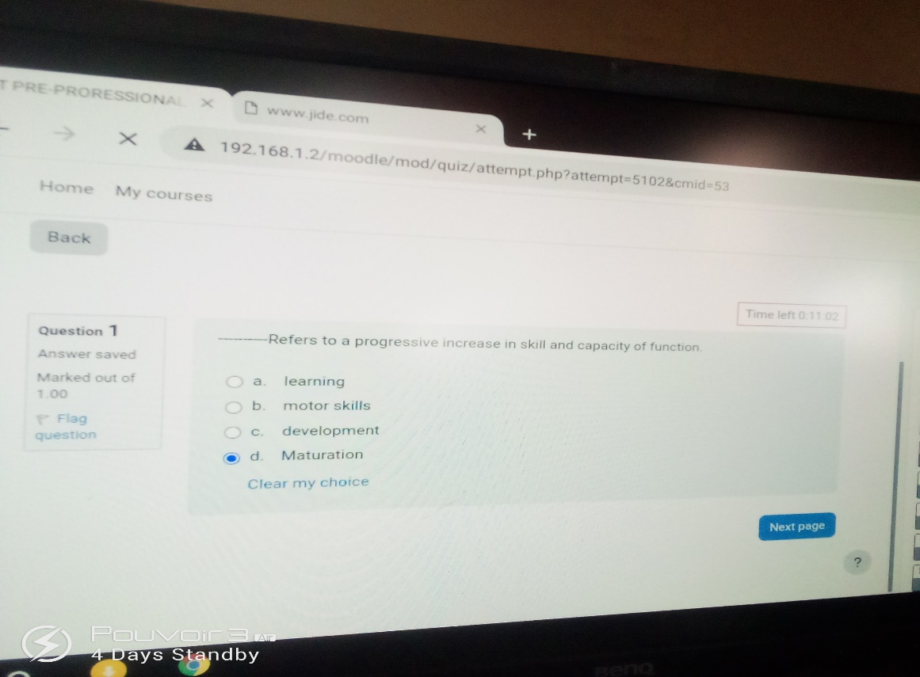
- When you click on the correct answer, it will automatically shade as you seen blue shade on the screen, then click on next page also with blue box by your right hand side. When you go to the next page and you have a confusion on the previous answer just click on previous, it will take you back, after you make the correction then click on next page.

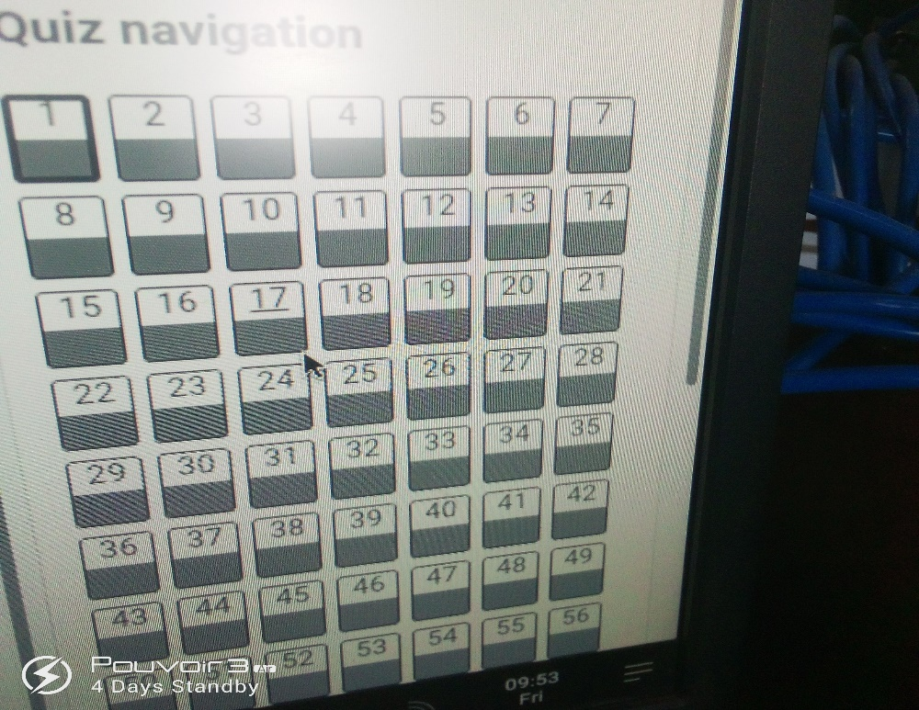

- During your exams check on the top by your right hand side there is an arrow click on it, all your answer you seen it was shade, if it’s not shade well or you skip the answer you will see it blank as showed above.

- Do not forget with your time it’s continue reading at the middle on the screen.
- When you finish all your exams/attempt you want make a submitting, just go to the last question or the digit number of you last question as showing bellow:-

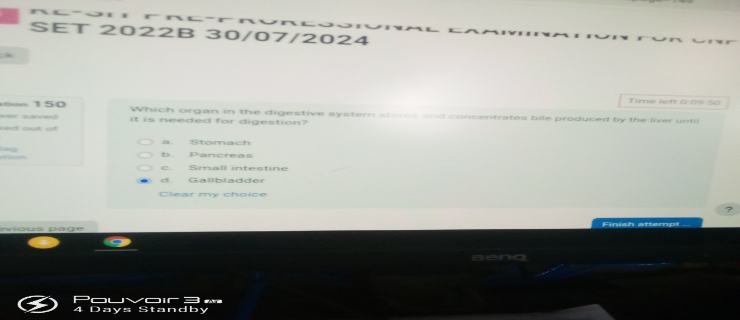
- After that, click on your last digit of your answer question and click on, then dialog box will appear as showing above click on (finish attempt).When you click on your finish attempt, make sure you scroll up and down and review your exams when you see that no any skip one as showing bellow click on submit all and finish.

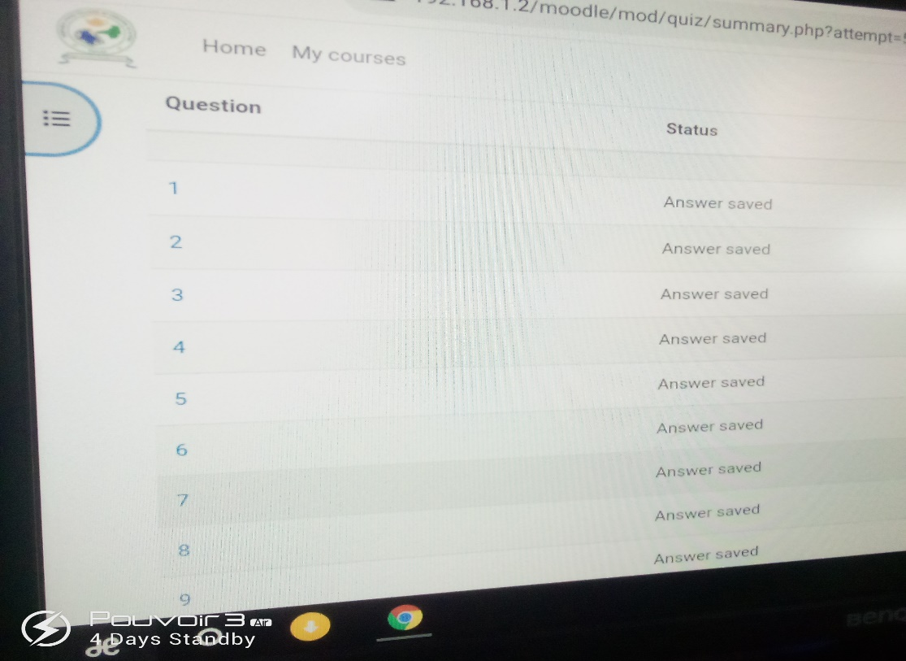
- Also another dialog box will appear after finish attempt as showing bellow click on (submit all and finish)on the bottom of your screen.
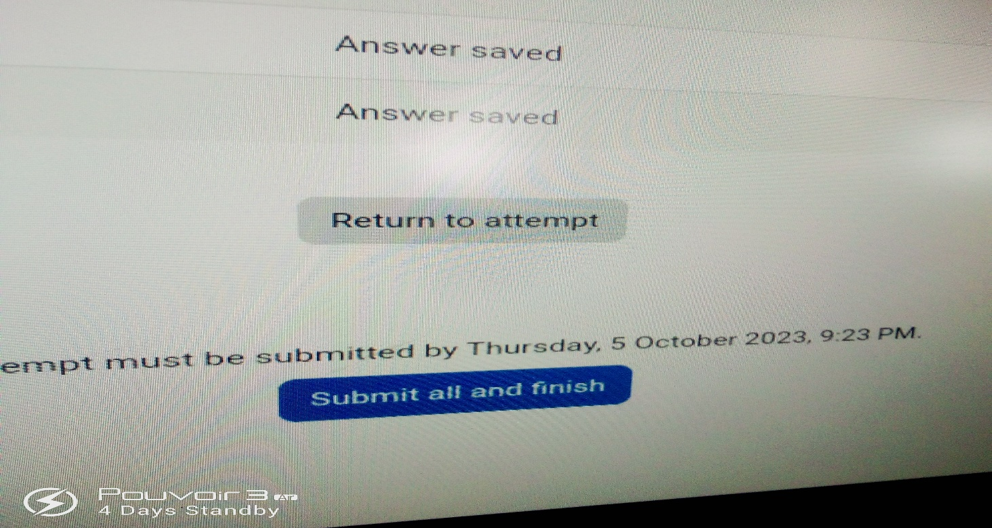

- Then second (2) dialog box will appear on the top right of your screen, after (submit all and finish) as showing bellow click on it will automatically (submit).

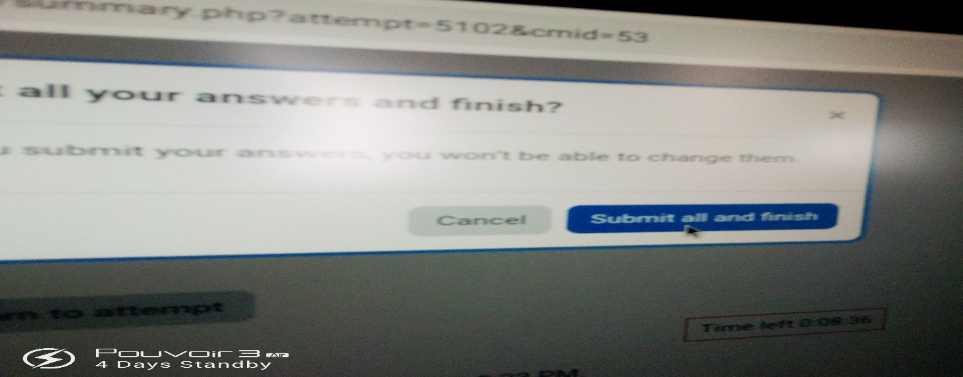

CIRCULATION
I humbly summit this report to circulate within College of Nursing Sciences Gusau, Zamfara State and the following constituted authorities are taken into considerations:
The Bsc Tech.
DEDICATION
This report is dedicated to my lovely parents Malam Sani Muhammad Nahayi and Malama. Khadija Ahmad, who gave me full hand of support, prayers and word of encouragement throughout my period of training making sure am financially free to enable me carryout the training successfully.
I will never forget my Director General Studies Department Mr Surajo Muhammad Kaura who is always there to see that I teach the students the right thing they ought to know, I say more grease to your experience.

ACKNOWLEDGEMENT.
My profound gratitude goes to my creator, the almighty God for the guidance and protection upon my life throughout this period of my training.
I also want to appreciate all the lecturers Department of computer science, The College of Nursing Sciences Gusau, Zamfara State. for their hand work through knowledge.
I cordially appreciate the effort of the staffs of College of Nursing Sciences Gusau, Zamfara State for their cooperation.
Special thanks to my parent, am really proud of them for their unrented effort, guidance and counseling. Also very huge thanks.
I also want to profound gratitude to my colleges I worked with,
Who provided a conducive environment for the exercise?
Finally, huge thanks to those who contributed in one way or to the other to make my practical training note /industrial training a success, that God in his infinite goodness guide and grant their heart desires.
ABSTRACT
This report is written base on my experience, which I acquired and impacted during my study/student industrial work experience scheme (SIWES) which I pass through at College of Nursing Sciences Gusau, Zamfara State.
All the experience acquired and impacted during this period has been analyzed and properly taken down. The knowledge includes:
Computer Tutor, Computer Operator, IT, CBT Training, Entrance Exams, Jamb Training, Semester Exams, Laminating, Photocopy, Repairs/maintenance, software installations, graphic artist and internet.

END OF THE PRACTICAL CLASS FOR COMPUTER BASE TRAINING (CBT) AND THE STUDENTS IT, JAMB, FORCES, ENTRANCE, SEMESTER AND COUNCIL EXAMINATIONS LECTURE NOTE.
Thanks’

